# **Weatherford King Heather Catlins Metal Bed**

**Description $1270**

Style Number: 76-126P

The Catlins Bed is a metal bed with a simple, casual style that works in nearly any type of bedroom or home. It is available in Queen and King sizes.

**Details**

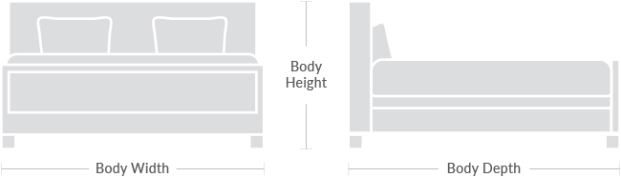**Body Depth:** 88.0  
  
**Body Height:** 62.0  
  
**Body Width:** 80.8